**What signal does Xi Jinping's close contact with new media send?**

Source: [Xinhuanet](http://news.xinhuanet.com/politics/2016-02/22/c_128739415.htm" \t "_blank)

Editor: Zhao Guangju

2016-02-22

<https://www.rmlt.com.cn/2016/0222/417939.shtml>

[Learning in Progress] With the leapfrog development of communication technology and the changes in audience psychology and habits, news work has ushered in major changes. Xi Jinping has assessed the situation and made major arrangements for media innovation and integration. Recently, Xi Jinping has intensively investigated three central news organizations, and the signal of accelerating innovation and integration has become stronger. Xinhuanet's "Lecture Institute" today launched "What Signals Does Xi Jinping's Close Contact with New Media Release" to interpret Xi Jinping's important remarks on this issue for you.

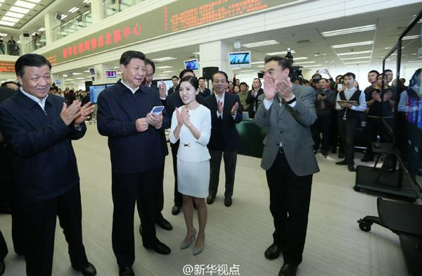

On the morning of February 19, Xi Jinping visited Xinhua News Agency for research. At the news release center, an editor said that the "live news" of the Xinhua News Agency client was popular, and many netizens liked the reporters. The General Secretary clicked the "Like for national journalists" page, and "Like +1" immediately flashed on the screen. The editorial staff told the General Secretary that your encouragement is our motivation. Photo by Xinhua News Agency reporter Lan Hongguang

February 19 was an extremely busy day for General Secretary Xi Jinping, and it was also an extremely active day for major media websites and the "two microblogs and one terminal". In the morning, Xi Jinping visited three central news organizations, People's Daily, Xinhua News Agency, and China Central Television, and presided over a symposium on the party's news and public opinion work in the afternoon.

"The General Secretary visited the central media for research today. The speed of reporting was so fast that it instantly went viral!" A reporter's sigh reflects the new trend and new pattern of news and public opinion work: new media has become the main battlefield for news competition and a new front for the party's public opinion work. This is also a major concern of Xi Jinping during this research.

"The Party's news and public opinion work is an important task of the Party and a major issue in governing the country and maintaining national security." With the leapfrog development of communication technology and changes in audience psychology and habits, news work has ushered in major changes. Xi Jinping has assessed the situation and made major arrangements for media innovation and integration, and has put forward stricter requirements and higher expectations for the Party's news team.

**Strengthening Internet thinking is an important approach**

Xi Jinping once emphasized on propaganda and ideological work that we must keep the overall situation in mind, grasp the general trend, focus on major issues, find the right entry points and focus points for work, and plan according to the situation, act in response to the situation, and follow the trend.

The booming development of the Internet is one of the "big trends" in Xi Jinping's eyes. Data shows that by the end of 2015, the number of mobile Internet users in my country alone reached 600 million. With the deep popularization of the Internet, the mobile Internet era has been fully opened.

According to the "Selected Works of Xi Jinping on Comprehensively Deepening Reform", Xi Jinping pointed out in his speech to the responsible comrades of propaganda work at all levels that many people, especially young people, basically do not watch mainstream media and get most of their information from the Internet. We must face up to this fact, increase our efforts, and seize the initiative in this public opinion battlefield as soon as possible, and we must not be marginalized. We must solve the problem of "skill panic" and truly become experts in using new means and methods of modern media.

During his visit to three central news organizations, Xi Jinping showed particular concern and attention to the new technologies, new formats, and new mechanisms of news dissemination spawned by the Internet. He not only listened to reports, but also tried them out many times. He conducted a detailed investigation of the "Internet thinking" as the entry point for innovative integration work. He was concerned about the process of building a new mainstream media from "addition" to "integration".

At Xinhua News Agency, Xi Jinping personally clicked on the screen of his mobile phone and praised journalists across the country through the Xinhua News Agency client; picked up a handheld video live cloud terminal and tried shooting at the accompanying personnel to experience the working status of Xinhua News Agency reporters; and connected with Xinhua News Agency reporters who were interviewing in Lankao County, Henan Province through the remote command system of the all-media reporting platform. When visiting the "History and Development" theme exhibition of Xinhua News Agency, he heard that Xinhua News Agency has established more than 180 overseas branches and saw that Xinhua News Agency has equipped reporters with modern equipment such as maritime satellites and drones. The general secretary nodded in appreciation. Xinhua News Agency's robot writing system "Kuai Bi Xiao Xin", Xinhua Silk Road Database, China Photo Archives Data Management System, overseas social media and other special products and services have also aroused Xi Jinping's interest. He affirmed Xinhua News Agency's efforts to develop new media business, innovate expression forms, and enhance the influence of news dissemination, and praised "Xinhua News Agency's cause has made great progress."

At the People's Daily, Xi Jinping personally clicked on the keyboard and extended Lantern Festival greetings to the people of the whole country through "two microblogs and one terminal"; he also connected with the villagers of Chixi Village in Ningde City, Fujian Province through the People's Daily video and had a "face to face" exchange with them.

At CCTV, Xi Jinping had a video link with CCTV's North American branch to learn about the construction and operation status and to greet those working overseas.

More than a month ago, when Xi Jinping was inspecting the People's Liberation Army Press, he also tapped on the keyboard and sent a Weibo message to wish the officers and soldiers a happy new year.

Xi Jinping's close contact with new media has not only attracted the attention of netizens, but also sent a strong signal to the national media - this is Xi Jinping's high recognition and strong support for the integrated development of traditional media and emerging media, and a wholehearted "thumbs-up" for innovative integration.

The words were sincere and full of hope: "Where the readers are, where the audience is, where the tentacles of publicity and reporting should be extended, and where the focus and foothold of publicity and ideological work should be placed. We must follow the general trend of Internet development, be bold in innovation and reform, and use the characteristics and advantages of the Internet to promote all-round innovation in concepts, content, methods, systems and mechanisms."

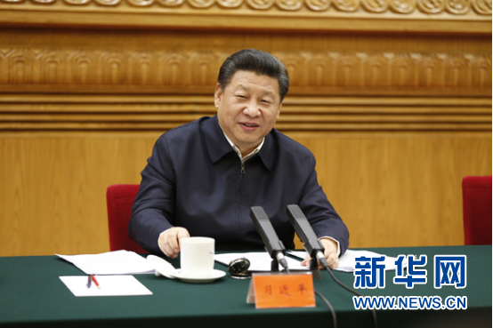

On February 19, Xi Jinping, General Secretary of the CPC Central Committee, President of the People's Republic of China, and Chairman of the Central Military Commission, presided over a symposium on the Party's news and public opinion work in Beijing and delivered an important speech. Photo by Xinhua News Agency reporter Ju Peng

**Using advanced technology to support content construction**

On February 19, after conducting field research at three central news organizations, Xi Jinping presided over a symposium on the Party's news and public opinion work. Xi Jinping emphasized that the Party's news and public opinion work adheres to the principle of party spirit, and the most fundamental thing is to uphold the Party's leadership over news and public opinion work. The media sponsored by the Party and the government are the propaganda positions of the Party and the government, and must be named after the Party. He summarized the responsibilities and missions of the Party's news and public opinion work under the conditions of the new era in 48 words: hold high the banner, guide the direction, focus on the center, serve the overall situation, unite the people, boost morale, shape the atmosphere, gather people's hearts and minds, clarify fallacies, distinguish right from wrong, connect China and foreign countries, and communicate with the world.

In today's world, communication methods are changing with each passing day. Advanced ideas, without the support of advanced communication methods, will hardly be deeply rooted in people's hearts; correct propositions, without the rapid and diverse communication of advanced technologies, will not be able to effectively occupy the public opinion front.

In view of the new characteristics of the times, Xi Jinping pointed out that as the situation develops, the Party's news and public opinion work must innovate concepts, content, genres, forms, methods, means, formats, systems, and mechanisms to enhance its pertinence and effectiveness. We must adapt to the trend of segmented and differentiated communication and accelerate the construction of a new pattern of public opinion guidance. We must promote integrated development and take the initiative to leverage the advantages of new media communication. We must seize opportunities, grasp the rhythm, pay attention to strategies, focus on timeliness, effectiveness, and reflect the requirements of timeliness, effectiveness, and effectiveness. As early as the fourth meeting of the Central Leading Group for Comprehensively Deepening Reforms held in August 2014, Xi Jinping proposed an innovative development approach to promote the deep integration of traditional media and emerging media with "advanced technology as the support and content construction as the foundation."

With the principle of upholding the Party's character as the foundation of content construction and advanced technology as the support of content construction, Xi Jinping's series of expositions have pointed out the direction for the Party's media to use the Internet to accelerate innovation and integration.

**Strengthening strength is the basis of integration**

The fourth meeting of the Central Leading Group for Comprehensively Deepening Reform reviewed and approved the "Guiding Opinions on Promoting the Integrated Development of Traditional and New Media". The top-level design of media innovation and integration was released.

At this meeting, Xi Jinping emphasized that we must adhere to advanced technology as the support and content construction as the foundation, promote the deep integration of traditional media and new media in terms of content, channels, platforms, operations, and management, and strive to create a group of new mainstream media with diverse forms, advanced means, and competitiveness, build several new media groups with strong strength, communication power, credibility, and influence, and form a three-dimensional, diverse, and integrated modern communication system.

At the Party’s news and public opinion work symposium on the 19th, Xi Jinping further proposed that we must strengthen international communication capabilities, enhance international discourse power, focus on telling China’s stories well, and at the same time optimize the strategic layout and strive to build a flagship foreign propaganda media with strong international influence.

Building a new type of media group and creating a flagship media for external propaganda is, after all, about constantly strengthening the media's own strength. In the current international public opinion environment, the status quo of Western media holding the right to speak has not fundamentally changed. my country's vital interests are still violated, and my country's correct propositions are still misunderstood and even black and white are reversed. The situation that the strength of my country's media is not in line with the country's status needs to be changed urgently.

As reform continues to deepen and foreign exchanges continue to expand, the need to improve the country's cultural soft power and defend the public opinion position is becoming more and more urgent. It is the media's responsibility to enhance its strength and enhance its international discourse power through innovation and integration.

To shoulder the heavy responsibility, we need to integrate news media resources and promote the sharing and integration of news production factors. We need to build a competitive new mainstream media, with strong strength as a guarantee, master new technologies, develop new formats, rebuild the editing and compiling process, upgrade information services, and win development advantages with content advantages.

Now is the decisive stage of building a moderately prosperous society in all respects. It is the right time for the Party’s news team to continue writing the glorious history and depicting the glorious chapter of the times. With the responsibility on our shoulders, we should bear in mind the expectations of the General Secretary: “Be the disseminators of the Party’s policies and propositions, the recorders of the times, the promoters of social progress, and the guardians of fairness and justice.” Accelerate innovation and integration, continuously enhance strength, and firmly occupy the commanding heights of international and domestic public opinion. (Reporter Wang Zihui)